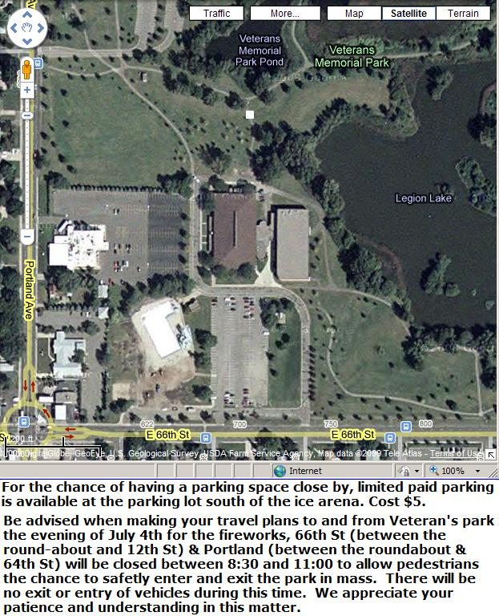
V
e
n
d
o
r
s
P
a
r
k
i
n
g
Entertainment
To Carnival
Fireworks Viewing Area South
Fireworks viewing area North

